EXP-2:LED CHASER

AIM: Design Christmas dual led chaser lights.

APPARATUS: Arduino, LED’s, wires, Breadboard

Circuit Diagram

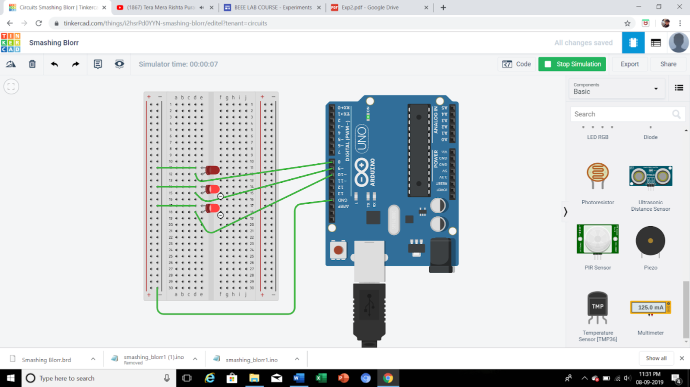

THEORY:

LED Chaser Circuit. This is the circuit of a simple LED chaser.

The LEDs lights one by one for a period of 1second and the cycle

repeats giving the running light appearance. The circuit uses two ICs

(one is 555) to drive the LEDs.

CONCEPT USED:

1. In this experiment,I have used the concept of pn junction

diode.

2. To make circuit on breadboard

3. Logic code for Arduino UNO, using loop statement.

1. LEARNI I have learnt to use Arduino board and how code works

to make light flash.

2. Arduino board has Digital pins and Analog pins.

3. Digital pin provides Input as well as Output, but Analog

pin provides only input.

4. The Arduino board has ~ sign in Digital pin side which is

also known as Pulse Width Modulation(PWM).

5. These pins help’s in getting analog results with digital

means.

6. How a circuit on breadboard is placed so that it can

work properly.

7. Digital Pin provides 5V Power supply to the circuit.

OBSERVATIONS:

1. If we connect the ‘n’ terminal of the LED to other

terminal except ground(GND), hence the circuit will be

incomplete and we cannot get the desired output.

2. I connected the ‘p’ terminal of the p-n junction diodes to

the Digital pins 9 in combination with the resistance, and ‘n’

3. If we connect the ‘p’ junction of LED to the 5V of

analog the the light will not blink it will remain to glow.

PROBLEM AND TROUBLESHOOTING:

1. I have connected the ‘p’ terminal of the LEDs to analog

side 5V terminal, but we cannot use that terminal

because it can take input only it cannot provide output

like digital terminals.

2.The LEDs were not glowing due to its loose connection.

By reinserting it again I was able to fix this issue.

3. I have written the code for 7 number digital pin instead

of 9

4.Then I rechecked the code and corrected the error.

PRECAUTIONS:

1. The connections should be tight and firm.

2. We have the check the voltage before operating the

board as high voltage might destroy the micro